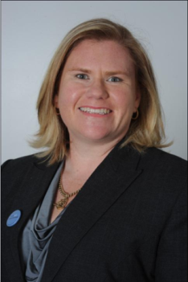
PMI Australia Conference 2013 – 21st Century Leadership
News from the Special Projects Director

The PMI Australia inaugural conference was held 1-3 May at the Sydney Convention and Exhibition Centre. As Conference Convenor I was proud (and very tired) at the end of the 3 days. The buzz was electric and all talk was on how much we are looking forward to next year’s conference to be held in Melbourne.
Our Master of Ceremonies Iain Fraser (Fellow PMINZ) kept everyone entertained and on time which was no small feat. With over 250 delegates attending the 3 day event, we were spoilt for choice with 7 keynote speakers, 22 stream presenters and 4 masterclasses all helping us on the journey to understand what it takes to be a relevant 21st Century Leader. With many coming from interstate and overseas, our delegates were able to connect with exhibitors as well as each other using our smart app and join in the fun of winning fantastic giveaways.
Here are a few of my highlights (come have a chat with me at the next PMI Sydney event for some more stories!) for those that couldn’t join us.
“Are you ready?”
Mark Langley, CEO and President of PMI opened the discussion around the challenges ahead. PMI's 2013 Pulse of the Profession finds ‘that organisations risk, on average, $135 million for every billion dollars spent. Organisations that focus on talent management, standardisation of tools and practices, and ensuring strategic alignment of projects are what we need to concentrate on.
“Are you a good Snakeholder?”
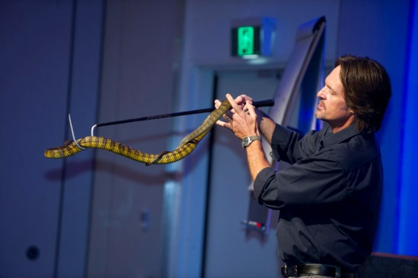
Who would have thought they would be up close and personal to so many snakes at a PM conference! It was such a great analogy using snakes and knowing how to handle them correctly to get the right outcome to show how we can deal with different stakeholders on our projects. Check out the video of our snakeholders here. Thank you to SSSafe Director Craig Adams and Jürgen Oschadleus for bringing this concept to our conference.
Figure 2 SSSafe Director Craig Adams
The Ultimate Tree House Project
We were proud to help Garry Nelson from PMINZ launch his new children’s book – The Ultimate Tree House Project. This book introduces basic Project Management concepts to children through an entertaining, funny story and simple lessons taught to one of the children by her father who is (of course) a Project Manager.
“If you aren’t failing very often, you aren’t trying very hard” Cassandra Wilkinson
Some food for thought came from a speaker who was not a project manager, but a manager of Sydney community radio station FBi, Cassandra Wilkinson. Having the freedom in your workplace to be able to go after the ‘dream’ and be supported by management inspires people to work at their best.
“Younger PM’s see project management as a core skill; older ones tend to consider it a niche capability.” Peter Taylor
Peter Taylor, author of the Lazy Project Manager touched on a very interesting point regarding our future project managers when looking at the new breed of PM’s coming into the workforce. Peter felt that technology and education will drive the next generation of project management practice.
“No one can whistle a symphony. It takes an orchestra to play it.” H.E. Luccock
The most important demonstration of leadership came from within my own team. I am privileged to have worked with such hardworking and dedicated project managers to deliver this conference. We had the vision of making a conference with a difference. All the delegates, speakers, exhibitors and sponsors; they helped make the conference the success. As the conference closed with us all up joining in a Zorba dance with the Corporate Imposter we left with a feeling of accomplishment and satisfaction. I can’t wait for the 2014 conference experience. I hope to see you there!
“If you are leading and no one is following; you’re just taking a walk!”
Afghani proverb
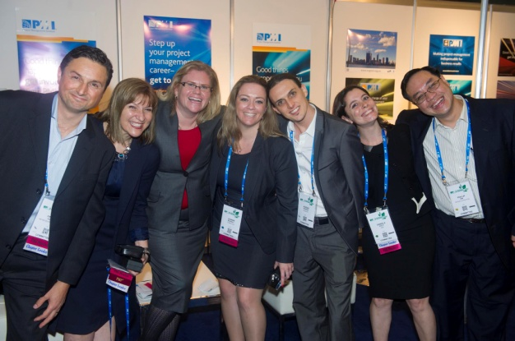
Figure 2 - The Organising Team - Frank Papa (MEL), Julia Checchia (SYD),
Kate Morris (SYD), Joanne Murray (SYD), Adrian Pearce (SYD), Daniela Polit (SYD), Phillip Ow (SYD)

